Peptide synthesis

ABSTRACT
Semaglutide is a long-acting glucagon-like peptide-1 (GLP-1) receptor agonist widely used in the treatment of Type 2 Diabetes Mellitus and obesity. It is a synthetic peptide analogue developed through advanced peptide engineering techniques to overcome the limitations associated with native GLP-1, particularly rapid enzymatic degradation and short plasma half-life. Structural modifications, including amino acid substitution and lipidation, significantly enhance its metabolic stability and therapeutic duration. Semaglutide contains a substitution of alanine with α-aminoisobutyric acid (Aib) at position 8, which improves resistance against degradation by dipeptidyl peptidase-4 (DPP-4). In addition, the attachment of a C18 fatty diacid side chain through a linker promotes reversible binding to plasma albumin, thereby reducing renal clearance and prolonging systemic circulation.
The synthesis of semaglutide is primarily carried out using Fmoc-based Solid-Phase Peptide Synthesis (SPPS), a highly efficient and reliable method for assembling peptide chains with precise amino acid sequences. The synthesis process involves sequential coupling of protected amino acids on a solid resin support, followed by selective deprotection, side-chain modification, cleavage from the resin, purification using reverse-phase high-performance liquid chromatography (RP-HPLC), and analytical characterization by techniques such as mass spectrometry and HPLC.
Semaglutide exerts its pharmacological action by stimulating glucose-dependent insulin secretion, suppressing glucagon release, delaying gastric emptying, and promoting satiety, thereby improving glycemic control and supporting weight reduction. Due to its prolonged half-life, semaglutide can be administered once weekly, improving patient compliance and therapeutic efficacy. The successful development of semaglutide demonstrates the importance of peptide engineering and modern synthetic methodologies in the design of long-acting peptide therapeutics for metabolic disorders. This review focuses on the structural modifications, peptide synthesis methodology, pharmacological significance, and therapeutic applications of semaglutide.

INTRODUCTION
Peptides are short chains of amino acids linked together by peptide bonds and generally consist of 2–50 amino acid residues. They play essential roles in numerous biological processes, including hormone regulation, cell signaling, immune responses, enzymatic activity, and metabolic control. Due to their high specificity, potent biological activity, and relatively low toxicity, peptides have emerged as an important class of therapeutic agents in modern pharmaceutical research. Unlike many conventional small-molecule drugs, peptide therapeutics can selectively interact with specific biological targets, thereby reducing off-target effects and improving therapeutic outcomes.
Over the past few decades, peptide-based drugs have gained significant attention in the treatment of chronic diseases such as cancer, cardiovascular disorders, infectious diseases, obesity, and Type 2 Diabetes Mellitus (T2DM). Among these conditions, diabetes and obesity have become major global health concerns due to their increasing prevalence and association with severe complications such as cardiovascular disease, neuropathy, nephropathy, and metabolic dysfunction. Consequently, there is a growing demand for safer and more effective therapeutic agents capable of providing long-term metabolic control.
One of the most important therapeutic targets in diabetes management is the glucagon-like peptide-1 (GLP-1) receptor pathway. GLP-1 is an incretin hormone secreted by intestinal L-cells in response to food intake. It plays a vital role in glucose homeostasis by stimulating glucose-dependent insulin secretion from pancreatic β-cells, suppressing glucagon release from α-cells, delaying gastric emptying, and promoting satiety. However, the clinical application of native GLP-1 is limited because it is rapidly degraded by the enzyme dipeptidyl peptidase-4 (DPP-4), resulting in an extremely short half-life of approximately 1–2 minutes.
To overcome these limitations, several synthetic GLP-1 receptor agonists have been developed with improved stability and prolonged duration of action. Among these, semaglutide has emerged as one of the most effective long-acting peptide therapeutics for the treatment of Type 2 diabetes and obesity. Semaglutide is a modified 31-amino-acid peptide analogue structurally derived from native human GLP-1. Through rational peptide engineering, semaglutide incorporates specific amino acid substitutions and chemical modifications that significantly improve its pharmacokinetic profile.
One major modification in semaglutide is the replacement of alanine at position 8 with α-aminoisobutyric acid (Aib), which enhances resistance to DPP-4-mediated enzymatic degradation. Another important modification is the attachment of a C18 fatty diacid chain through a hydrophilic spacer to the lysine residue at position 26. This lipidation promotes reversible binding to plasma albumin, reducing renal clearance and extending the peptide’s half-life to approximately one week. As a result, semaglutide can be administered once weekly, improving patient adherence and therapeutic effectiveness.
Semaglutide exhibits multiple pharmacological effects that contribute to its clinical efficacy. It enhances glucose-dependent insulin secretion, suppresses glucagon release, delays gastric emptying, and acts on the central nervous system to reduce appetite and promote weight loss. In addition to glycemic control, semaglutide has demonstrated cardiovascular benefits and significant efficacy in obesity management, making it one of the most successful peptide-based drugs developed in recent years.
The synthesis of semaglutide is achieved primarily through Fmoc-based Solid-Phase Peptide Synthesis (SPPS), a widely used technique in peptide chemistry. SPPS enables the stepwise assembly of amino acids on an insoluble resin support, allowing efficient synthesis of complex peptide sequences with high purity and precision. Following peptide assembly, additional modifications such as lipidation, purification, and analytical characterization are performed to obtain the final pharmaceutical product.
Advances in peptide synthesis and structural modification strategies have transformed naturally occurring peptides into clinically viable therapeutics with improved stability, bioavailability, and pharmacological performance. The development of semaglutide represents a major milestone in peptide drug design and highlights the growing importance of peptide engineering in modern medicine. This review focuses on the structural characteristics, synthesis methodology, pharmacological mechanisms, and therapeutic significance of semaglutide as a long-acting GLP-1 receptor agonist.
The peptide sequence of Semaglutide is closely related to the native human GLP-1 (glucagon-like peptide-1) sequence but includes specific structural modifications to improve stability and prolong its action.
Chemical Identity of Semaglutide
- Formula: 𝐶187 H291 N45 O59
- Molecular Weight: 4113.58
Amino Acid Sequence of Semaglutide
His–Aib–Glu–Gly–Thr–Phe–Thr–Ser–Asp–Val–Ser–Ser–Tyr–Leu–Glu–Gly–Gln–Ala–Ala–Lys–Glu–Phe–Ile–Ala–Trp–Leu–Val–Arg–Gly–Arg–Gly
semaglutide structure

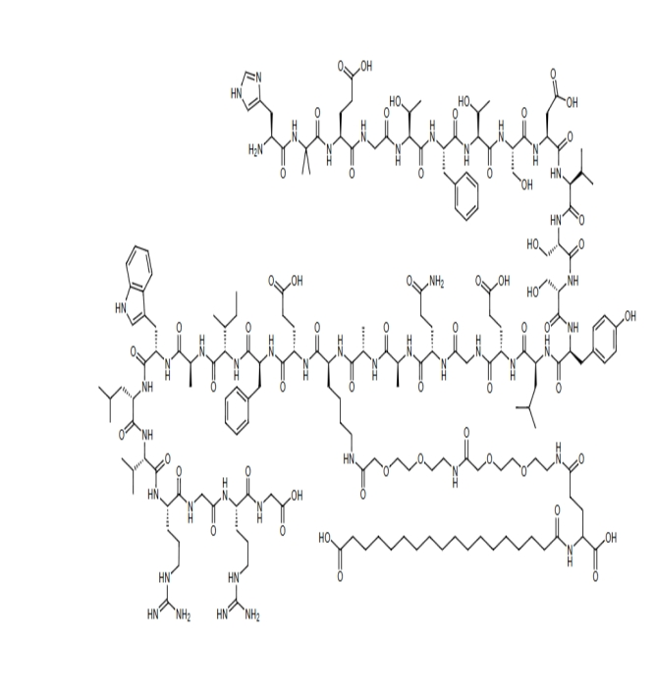

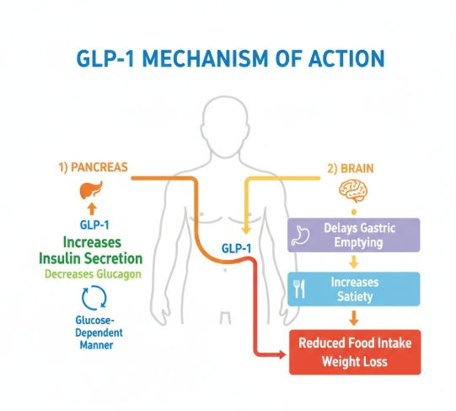
. Action on the Pancreas
The left side of the diagram represents the effect of GLP-1 on the pancreas.
- GLP-1 stimulates the pancreatic beta cells to increase the secretion of insulin.
- At the same time, it suppresses the release of glucagon from alpha cells.
- This process occurs in a glucose-dependent manner, meaning insulin is released mainly when blood glucose levels are elevated. Therefore, the risk of hypoglycemia is lower compared with some other antidiabetic drugs.
Physiological Outcome
- Increased insulin promotes uptake of glucose by tissues.
- Reduced glucagon decreases hepatic glucose production.
- Together, these actions help lower blood glucose levels and improve glycemic control.

2. Action on the Brain and Gastrointestinal System
The right side of the diagram illustrates the central and gastrointestinal effects of GLP-1.
a) Delayed Gastric Emptying
GLP-1 slows the movement of food from the stomach into the intestine. This delay:
- reduces the rapid rise in blood glucose after meals,
- prolongs the feeling of fullness after eating.
b) Increased Satiety
GLP-1 acts on appetite-regulating centers in the hypothalamus of the brain to:
- decrease hunger,
- increase satiety or fullness.
c) Reduced Food Intake and Weight Loss
Because patients feel full earlier and for a longer duration:
- caloric intake decreases,
- body weight gradually reduces.

LITERATURE REVIEW
Peptide therapeutics have become an increasingly important area of pharmaceutical research due to their high selectivity, potent biological activity, and improved safety profile compared to conventional small-molecule drugs. Despite these advantages, naturally occurring peptides often exhibit poor pharmacokinetic properties, including rapid enzymatic degradation, short plasma half-life, and low metabolic stability. These limitations have encouraged the development of chemically modified peptide analogues with enhanced therapeutic efficacy and prolonged biological activity.
Among peptide-based therapeutics, glucagon-like peptide-1 (GLP-1) receptor agonists have gained considerable importance in the management of Type 2 Diabetes Mellitus and obesity. GLP-1 is an incretin hormone secreted by intestinal L-cells following nutrient intake. It regulates glucose homeostasis by stimulating insulin secretion in a glucose-dependent manner, inhibiting glucagon release, delaying gastric emptying, and promoting satiety. However, endogenous GLP-1 is rapidly degraded by the enzyme dipeptidyl peptidase-4 (DPP-4), resulting in a half-life of only a few minutes, which limits its therapeutic utility.
To overcome these challenges, several synthetic GLP-1 receptor agonists have been developed with structural modifications designed to improve enzymatic stability and extend duration of action. Early GLP-1 analogues such as exenatide and liraglutide demonstrated improved glycemic control and established the clinical significance of incretin-based therapies. Building upon these developments, semaglutide was introduced as a second-generation GLP-1 analogue with enhanced pharmacokinetic and pharmacodynamic properties.
Semaglutide is a synthetic 31-amino-acid peptide structurally related to native human GLP-1 but modified through rational peptide engineering. One of the key structural modifications involves substitution of alanine at position 8 with α-aminoisobutyric acid (Aib), which provides resistance against DPP-4-mediated degradation. Another major modification is the attachment of a C18 fatty diacid moiety to the lysine residue at position 26 via a linker chain. This lipidation strategy increases reversible binding to serum albumin, reducing renal filtration and protecting the peptide from rapid enzymatic breakdown. These modifications collectively prolong the plasma half-life of semaglutide to approximately one week, allowing convenient once-weekly administration.
Several clinical studies have demonstrated the superior efficacy of semaglutide in improving glycemic control and reducing body weight compared to earlier GLP-1 receptor agonists. Clinical trials have reported significant reductions in HbA1c levels, improved insulin sensitivity, appetite suppression, and substantial weight loss in patients with Type 2 Diabetes Mellitus and obesity. Additionally, semaglutide has shown cardiovascular benefits, including reduction in major adverse cardiovascular events in high-risk patients.
The synthesis of semaglutide is primarily achieved using Fmoc-based Solid-Phase Peptide Synthesis (SPPS), which is one of the most widely used techniques for peptide production. SPPS allows sequential addition of protected amino acids to a growing peptide chain anchored on an insoluble resin support. The use of Fmoc chemistry provides mild deprotection conditions and compatibility with sensitive amino acid residues. Following peptide chain assembly, selective side-chain modification and lipidation are carried out to obtain the final semaglutide structure.
After synthesis, the crude peptide product contains impurities such as truncated peptides, deletion sequences, and side products. Therefore, purification is an essential step in peptide manufacturing. Reverse-phase high-performance liquid chromatography (RP-HPLC) is commonly employed to isolate semaglutide with high purity and structural integrity. Analytical characterization techniques such as mass spectrometry, HPLC, amino acid analysis, and peptide mapping are further used to confirm molecular weight, sequence accuracy, and purity.
Recent advancements in peptide drug delivery have also contributed to the development of oral semaglutide formulations. Traditionally, peptide drugs require parenteral administration because of poor gastrointestinal stability and low oral bioavailability. However, novel absorption-enhancing technologies have enabled the successful oral delivery of semaglutide, representing a major advancement in peptide therapeutics.
Overall, the successful development of semaglutide highlights the importance of peptide engineering, structural modification, and advanced synthetic methodologies in modern pharmaceutical science. The combination of improved stability, prolonged half-life, and enhanced therapeutic efficacy has established semaglutide as a leading peptide-based drug for metabolic disorders.

METHODOLOGY
Solid-Phase Peptide Synthesis (SPPS)
Semaglutide is synthesized primarily using Fmoc-based Solid-Phase Peptide Synthesis (Fmoc-SPPS), a widely employed method for the efficient assembly of peptide chains with precise amino acid sequences. In SPPS, the growing peptide chain remains covalently attached to an insoluble polymeric resin throughout the synthesis process. This allows excess reagents and byproducts to be removed easily by filtration and washing after each reaction cycle.
The Fmoc (9-fluorenylmethoxycarbonyl) group is used as a temporary protecting group for the α-amino group of amino acids during peptide chain elongation. Fmoc protection is advantageous because it can be removed under mild basic conditions without affecting acid-labile side-chain protecting groups.

Principle of Fmoc-SPPS
In Fmoc-SPPS, the first amino acid is attached to a solid support such as Wang resin through a linker. The peptide chain is then elongated sequentially from the C-terminal to the N-terminal end through repeated cycles of:

- Fmoc deprotection
- Washing
- Amino acid activation
- Coupling reaction
- Final cleavage and purification
This method enables high sequence accuracy, efficient purification, and automation of peptide synthesis.
Material/Reagent | Role
Wang Resin | Solid support for peptide synthesis
Fmoc-Protected Amino Acids | Building blocks of peptide chain
DMF | Coupling reagents for activation
Piperidine | Coupling additives to reduce racemization
DIPEA | Base used during coupling
TFA | Cleavage and deprotection reagent
Acetonitrile | HPLC solvent
Diethyl Ether | Peptide precipitation

Resin Swelling
Before synthesis, Wang resin is swollen in DMF or dichloromethane (DCM) for approximately 30–60 minutes at room temperature. Swelling increases solvent penetration into the resin matrix, improving reagent accessibility and coupling efficiency.
Attachment of First Amino Acid
The first Fmoc-protected amino acid is attached to the Wang resin through ester bond formation using coupling reagents such as DIC in the presence of additives. This step establishes the C-terminal residue of the peptide sequence.
Fmoc Deprotection
After attachment of the first amino acid, the Fmoc protecting group is removed using 20% piperidine in DMF.
This reaction exposes the free amino group required for the next coupling cycle.
Amino Acid Activation and Coupling
The incoming Fmoc-protected amino acid is activated using coupling reagents such as HBTU, HATU, or DIC in the presence of DIPEA.
The activated amino acid reacts with the free amino group on the resin-bound peptide, resulting in peptide bond formation.
Washing Cycles
After each deprotection and coupling step, the resin is washed repeatedly with DMF and DCM to remove excess reagents, byproducts, and residual solvents. Proper washing is essential to prevent side reactions and improve peptide purity.
Monitoring of Coupling Completion
The Kaiser test is commonly used to monitor coupling efficiency. In this test, free primary amines react with ninhydrin to produce a blue coloration, indicating incomplete coupling. A negative test indicates successful peptide bond formation.
Repeated Elongation Cycles
The cycles of deprotection, activation, coupling, and washing are repeated sequentially until the complete semaglutide peptide chain is assembled on the resin support.

Side-Chain Protection
Reactive side chains of amino acids are protected during synthesis to prevent unwanted side reactions.
Amino Acid | Protecting Group
Lysine | Boc
Arginine | Pbf
Histidine | Trt
Aspartic Acid | OtBu
Serine | tBu
These protecting groups remain intact during peptide elongation and are removed during final acid cleavage.
FMOC Amino acid Reaction
Protection of Glutamic Acid Carboxyl Group (tert-Butyl Ester Formation)
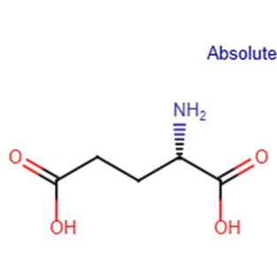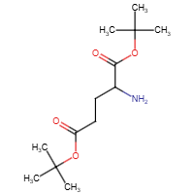

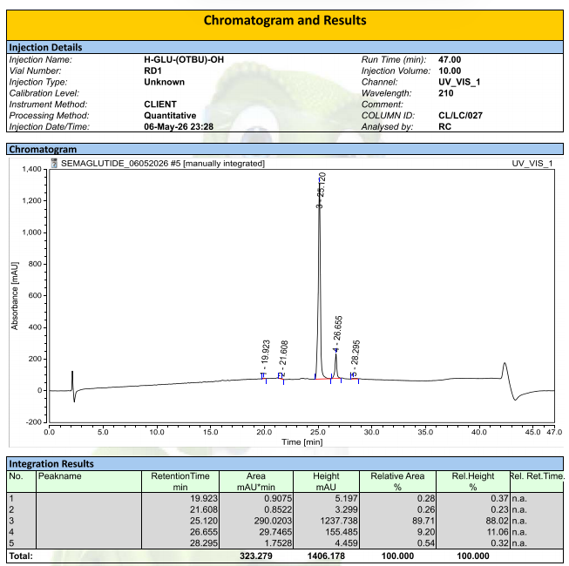

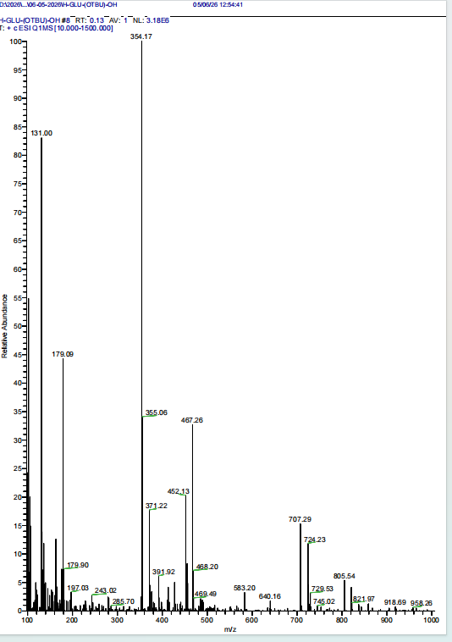

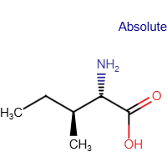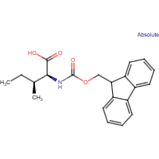

Lipidation and Structural Modification
A critical step in semaglutide synthesis is the attachment of a C18 fatty diacid chain to the lysine residue through a linker molecule. This lipidation enhances albumin binding and prolongs plasma half-life.
Additionally, alanine at position 8 is replaced with α-aminoisobutyric acid (Aib) to improve resistance to DPP-4 degradation.
Final Cleavage from Resin
After completion of peptide assembly, the peptide is cleaved from the resin using a trifluoroacetic acid (TFA) cleavage cocktail containing scavengers such as water and triisopropylsilane (TIS).
This step simultaneously removes acid-labile side-chain protecting groups.
Peptide Precipitation
The crude peptide is precipitated using cold diethyl ether, followed by centrifugation and drying under vacuum.
Purification by RP-HPLC
The crude semaglutide peptide is purified using reverse-phase high-performance liquid chromatography (RP-HPLC) with water and acetonitrile containing 0.1% TFA as mobile phases. Gradient elution is used to separate semaglutide from impurities and truncated peptide sequences.
Analytical Characterization
The purified peptide is characterized using:
- HPLC for purity analysis
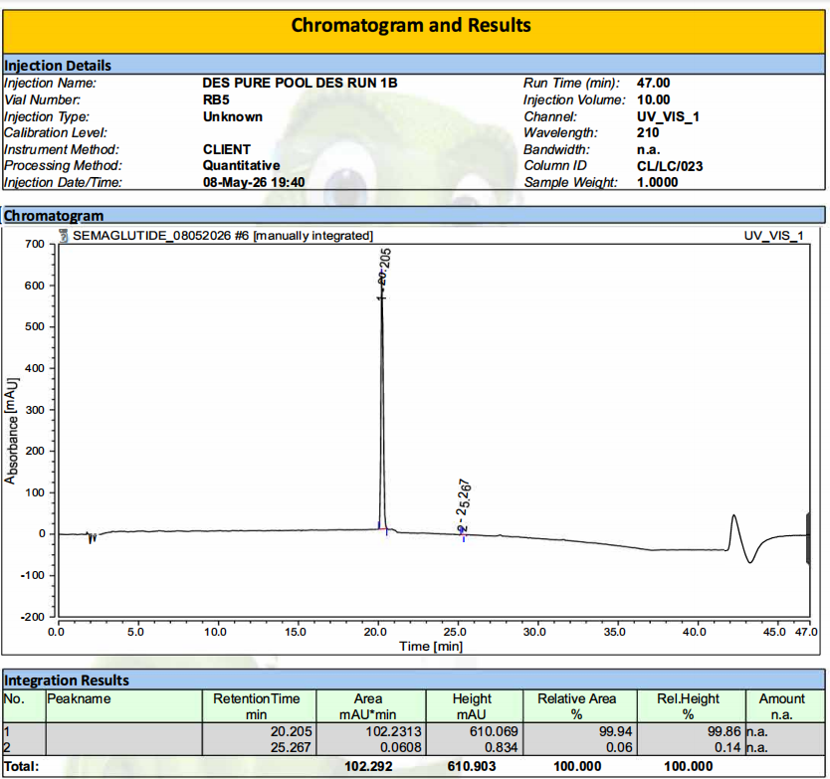
- Mass spectrometry for molecular weight confirmation
- Amino acid analysis
- Peptide mapping techniques

Result
The synthesized peptide was purified using High-Performance Liquid Chromatography (HPLC) and characterized by Mass Spectrometry (MS), confirming the desired molecular structure and high purity of the final product. Lipidation of the peptide was successfully incorporated, contributing to the enhanced pharmacokinetic properties of semaglutide.

Conclusion
Semaglutide is a long-acting GLP-1 receptor agonist used for the treatment of type 2 diabetes and obesity. It is synthesized using Solid-phase peptide synthesis with the Fmoc strategy. Fmoc-protected amino acids are sequentially coupled on a solid resin support to form the peptide chain.
A special lipidation step involving attachment of a C18 fatty acid improves albumin binding and extends the drug’s half-life. During synthesis, monitoring tests such as the Kaiser test are used to confirm successful coupling reactions. The final peptide is purified using HPLC and characterized by mass spectrometry.

